TRISTAN GUERIN:
I was tasked with analyzing the I-Beam Profile with an ABAQUS model. The Project document gave me all the material properties, which included Failure Stress=400[MPa], Modulus of Elasticity=200[GPa], and Poisson’s Ratio=0.3. The Project document also Provided the general structure design with the support locations and the load location and magnitude. A pinned support was at (0,0) and a roller support was at (4,0). The load was a line load with a magnitude of 1000 [N/m] over a 2-meter beam. The line load was applied between (4,0) and (6,0). The project also specified that we should have a safety factor of 1.5, so I determined that the maximum failure stress of our deign could not exceed 266.6 [MPa]. I ran multiple iterations of the beam, and I ended up with a maximum Von Misses stress of 260.7[MPa] and achieved a cross-sectional area of 1.596*10⁻⁴ (m²). Von Misses stress was chosen over the Maximum in-plane stress because it accounts for stresses acting in all three dimensions (3D) while the max in-plane stress accounts for only two dimensions (2D). The dimensions were chosen via trial and error and are shown in figure 1.

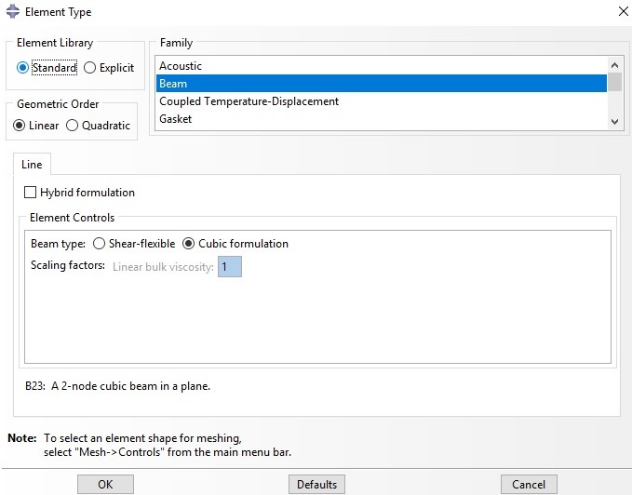
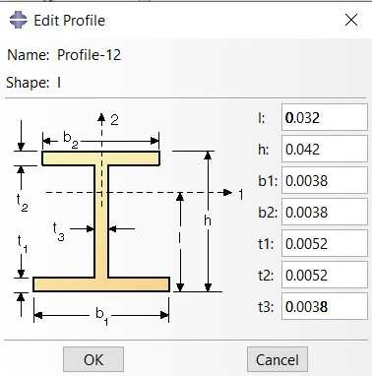
Figure 1 cross sectional dimensions of the I-Beam: Figure 2: Mesh Size

An arbitrary mesh size of 0.01 was used. See Figure 2
While the profile is technically an I-Beam it looks more like a solid rectangle with a height of 4.2 [cm] and a width of 0.38 [cm].

